

Lab Experiment- 14
Alpha-Beta Pruning Algorithm for Gaming

Aim
To implement the Alpha-Beta Pruning algorithm for a two-player game using Python.

Objective
To improve the efficiency of the Minimax algorithm by eliminating branches that cannot affect the final decision.

Algorithm
- Start the game and initialize the game tree.
- Set alpha = -∞ and beta = +∞.
- Check whether the current state is a terminal state.
- Generate possible moves.
- For the MAX player, select the maximum value and update alpha.
- For the MIN player, select the minimum value and update beta.
- If beta <= alpha, prune the remaining branches.
- Continue until the best move is found.
- Display the optimal value or move.
- Stop.

FlowChart
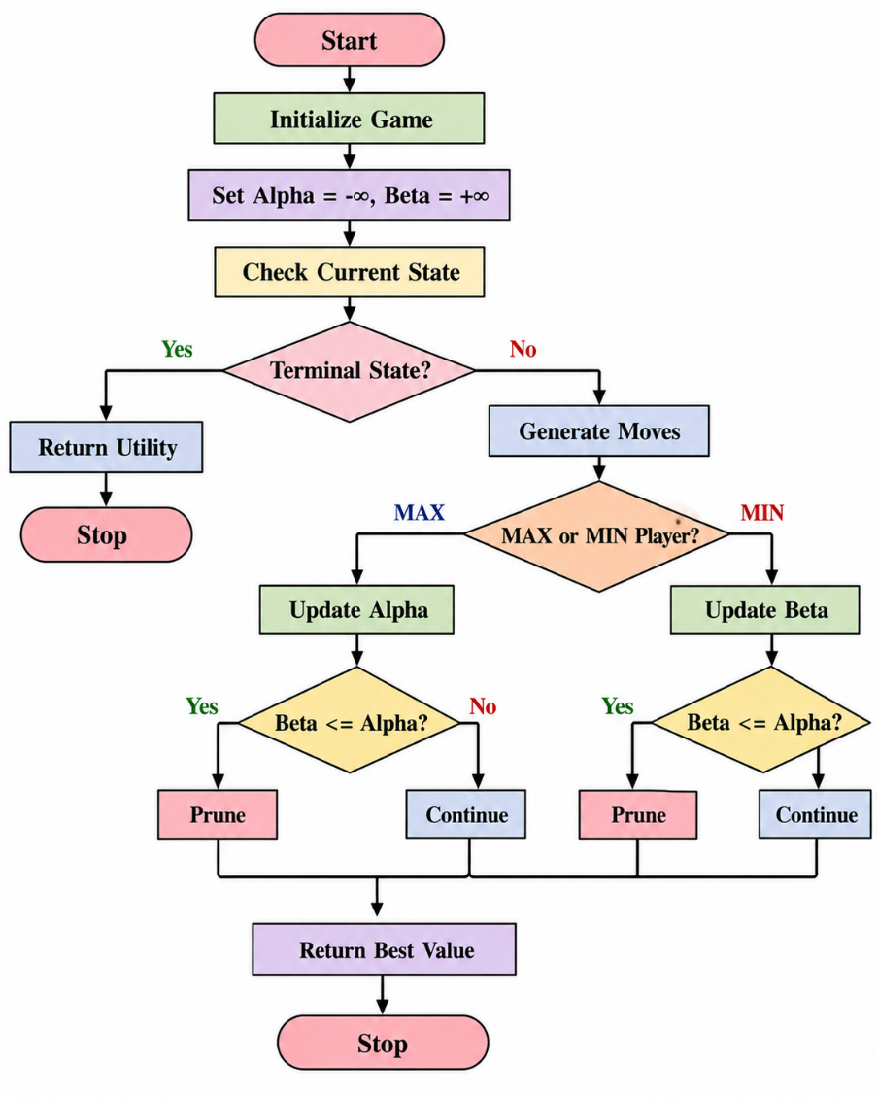
Code
def alpha_beta(depth, node_index, maximizing_player,
values, alpha, beta):

# Terminal node
if depth == 3:
return values[node_index]

if maximizing_player:
best = float('-inf')

for i in range(2):
value = alpha_beta(
depth + 1,
node_index * 2 + i,
False,
values,
alpha,
beta
)

best = max(best, value)
alpha = max(alpha, best)

# Alpha-Beta pruning
if beta <= alpha:
break

return best

else:
best = float('inf')

for i in range(2):
value = alpha_beta(
depth + 1,
node_index * 2 + i,
True,
values,
alpha,
beta
)

best = min(best, value)
beta = min(beta, best)

# Alpha-Beta pruning
if beta <= alpha:
break

return best

values = [3, 5, 2, 9, 12, 5, 23, 23]

alpha = float('-inf')
beta = float('inf')

result = alpha_beta(
0, 0, True,
values, alpha, beta
)

print("Optimal Value:", result)
Output
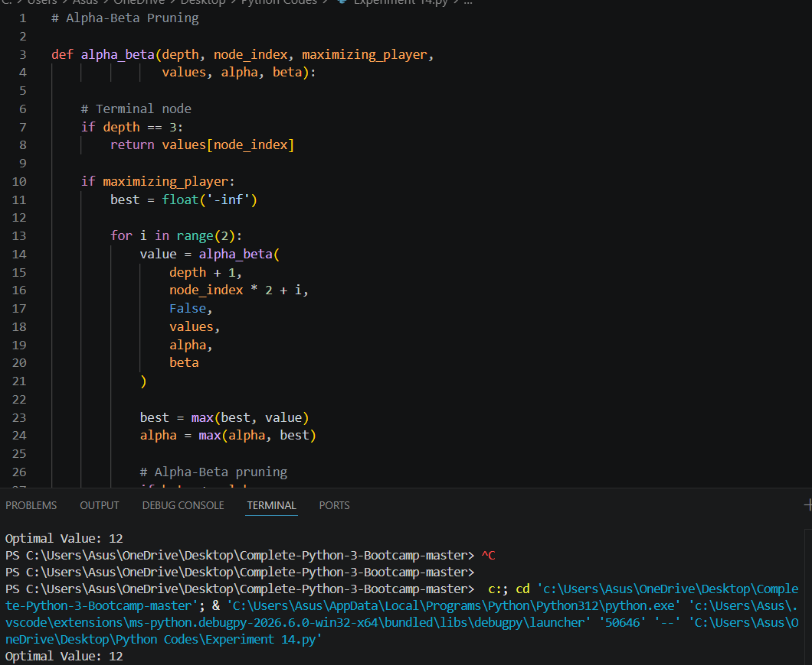

Result
The Alpha-Beta Pruning algorithm was successfully implemented to find the optimal value while eliminating unnecessary branches.

Conclusion
Alpha-Beta Pruning improves the Minimax algorithm by pruning branches that do not need to be evaluated. It produces the same optimal result as Minimax while reducing the number of nodes examined.

